**USER MANUAL FOR QUICK DINER WEBSITE**

Eramyo Calvin 20/U/2074/EVE

Odokonyero Gerald 20/U/7805/PS

Kabatuku Nester 20/U/7815/PS

Nanyondo Carol 20/U/2033/EVE

Beguya Melissa Deborah 20/U/7756/PS

**CUSTOMER SIDE**

User types the URL for the website

User scrolls through the available products displayed on the interface

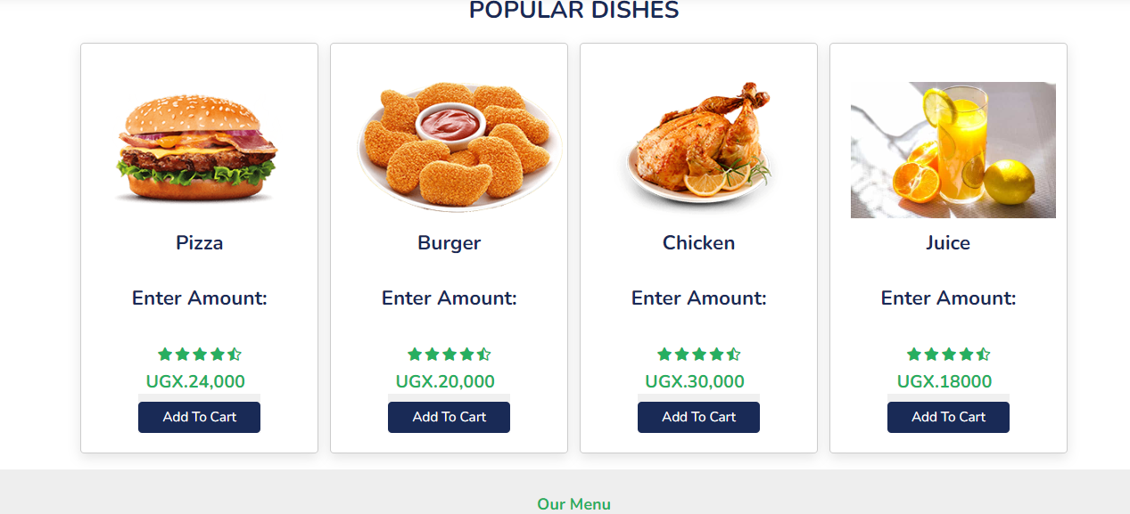

User can choose to like a product by clicking the like button.

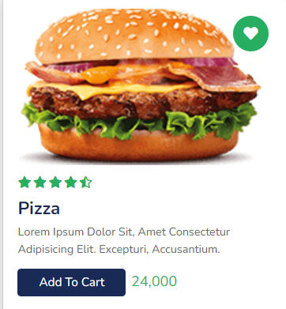

User can add an item to cart by entering the quantity and clicking “Add to cart”.



If the user isn’t logged in, he /she is forwarded to the login page

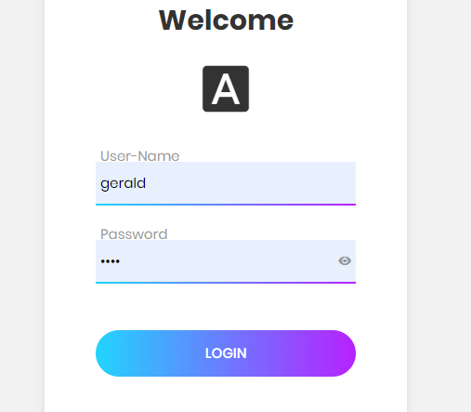

If the user already has an account, they enter their username and password and proceed to login, there after they are referred back to the home page and they can proceed to add item to the cart

Users are forwarded to cart when they add an item if the approve of the items, then they approve of the items then they can checkout

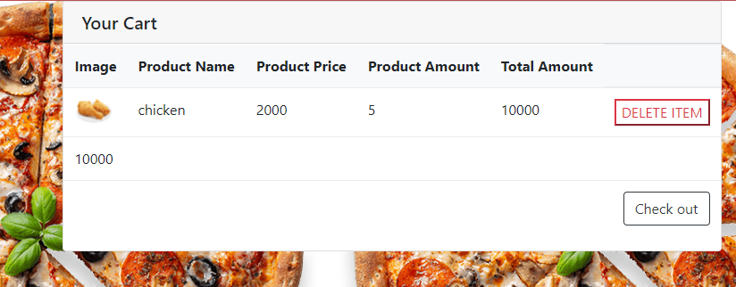

Else if the user has no account, they click on sign up where they can be registered

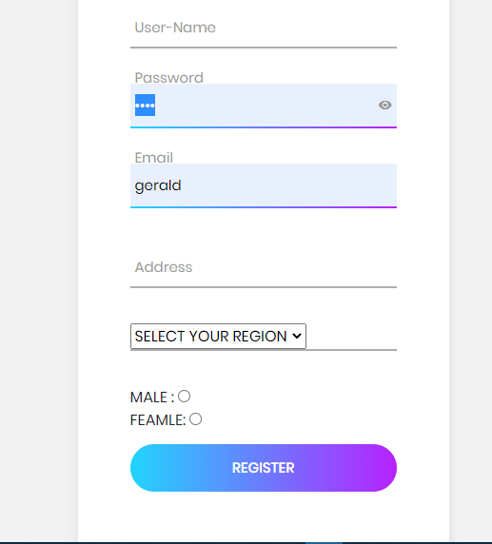

**Admin Dashboard**

Type the URL for the Admin Dashboard

User will be required to signup then login to the system

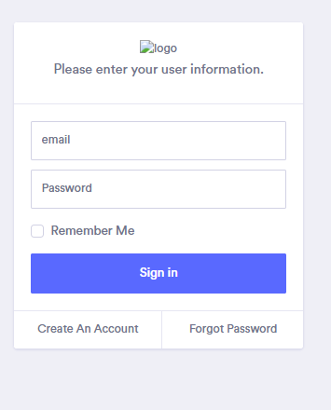

User lands on the dashboard containing a summary of information from all modules e.g., the total sales, total orders, etc.

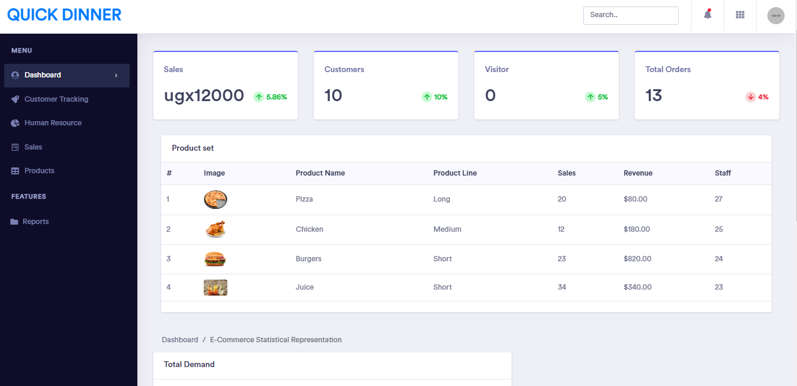

The user can navigate to the side bar which contains a menu with four options i.e., dashboard, customer tracking, Human resource, sales, products and reports

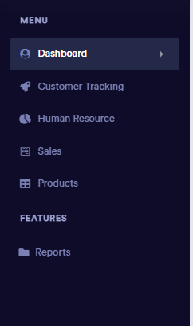

Each option leads you a separate screen

1. **Customer Tracking**

This shows graphical representation of the trend of customer preferences by the following categories i.e., Female, Male and Region

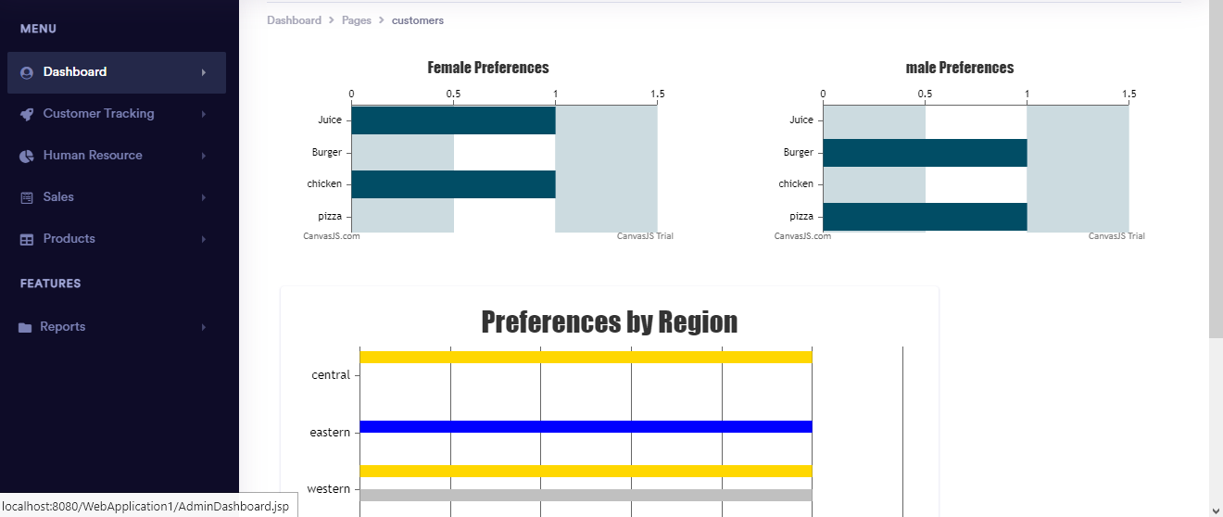

**Human Resource**:

This screen meant for employee management i.e.

Registration and Re-allocation: A user clicks on the pencil icon to register employees

User clicks the re-allocate button to re-allocate the staff to different product lines

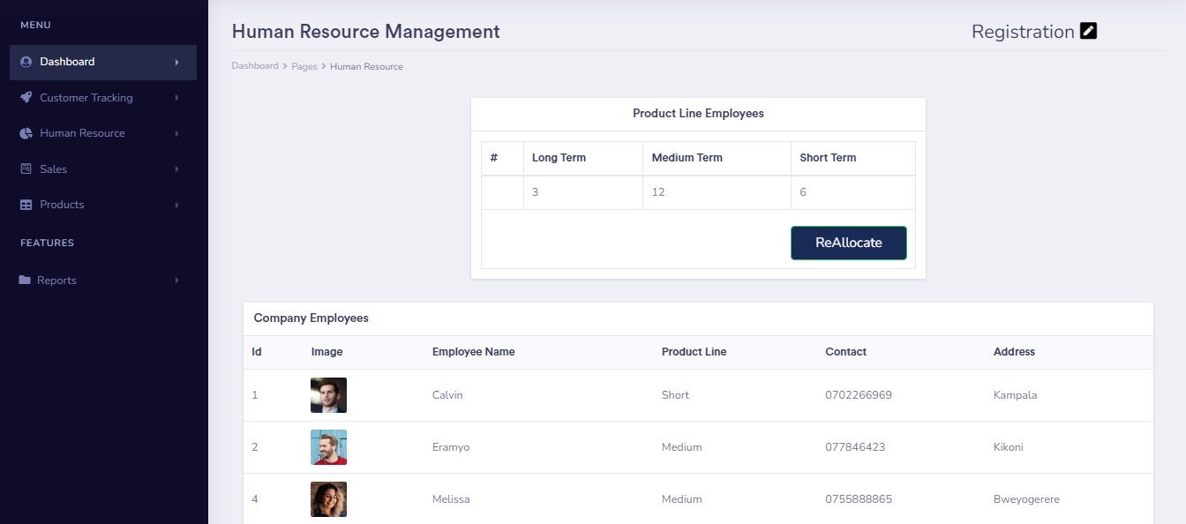

**Sales**

This shows a summary of the sales and revenue for each product category

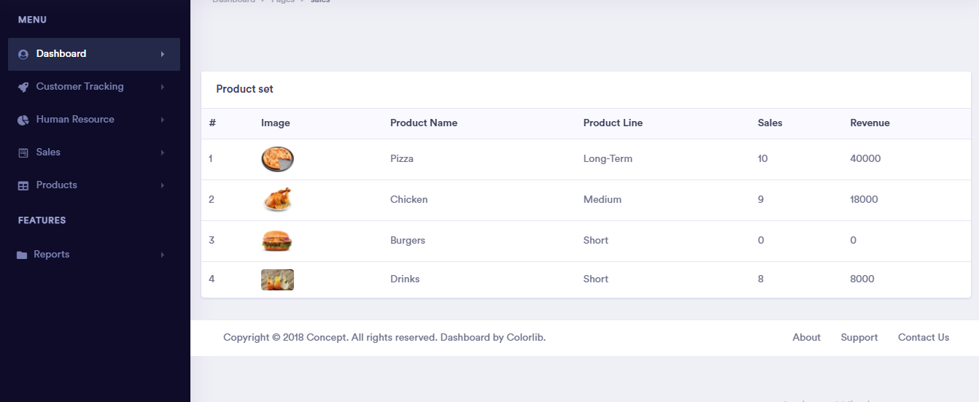

**Product Management**

This is the screen for product management

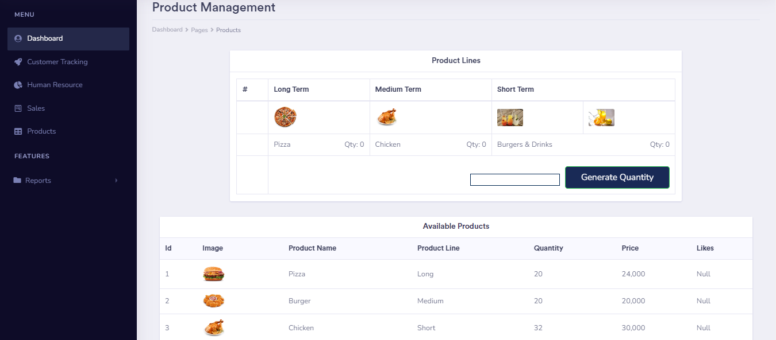

It has a table showing the different product in each product line plus their quantities

It also has a table displaying all products from the database

It has a form for entering a new product to the database

**Reports:**

this contains a report from all modules

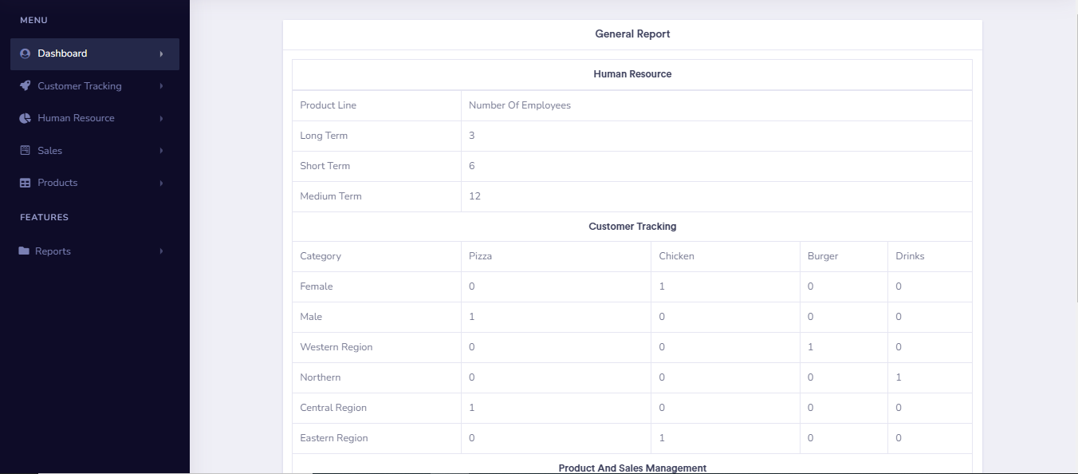

**Contributions by each Group Member**

HR Management :- Eramyo Calvin

Product And Sales Management :- Beguya Melissa Deborah

Customer Base Tracking And Advisory Module :- Nanyondo Carol

Reporting :- Kabatuku Nester

System Configuration, Dashboard and Authentication :- Odokonyero Gerald

GitHub Link:  [https://github.com/Quick-Dinner/QuickDinner]( https:/github.com/Quick-Dinner/QuickDinner)